Users interact with an Amazon front-end to initiate a package purchase order.

To complete a purchase order, users MUST specify a destination address (given by two int32s, "destinationx," "destinationy"). As part of the order creation process, they MAY optionally request that their existing UPS account be linked to this order to enable tracking via UPS login. If users request the UPS account linking option, they MUST specify an additional UPS ID (upsid string). This upsid SHOULD correspond to a valid and existing UPS account.

Once a user enters a valid order request, Amazon MUST generate an AOrderATruck message, which (along with the above user-entered data) will include a newly constructed package ID (int64 packageid) as well as the warehouse address where the requested item is located (given by two int32s, "warehouselocationx," "warehouselocationy") and a warehouse id (another int32) that is associated with the given warehouse. This message is then sent to UPS.

UPS receives the AOrderATruck message from Amazon, processing order information and associating the order with an existing UPS account if the UPS ID string has been specified. After processing, UPS will send a truck to receive the package at the selected warehouse location and MUST respond with a UTruckArrive message containing the original packageid and a truckid (int64) corresponding to the truck UPS sent to pick up the specified order.

Amazon receives the UTruckArrive message and MUST respond with an AStartDeliver message once the truck has been loaded with the package specified in UTruckArrive. AStartDeliver will contain the same packageid along with a newly created segnum (int64) that is a serialized value that signifies the order in which the correctly loaded trucks have left the warehouse.

UPS receives the AStartDeliver message, which signals that the delivery truck driver is en route to the destination address specified in the original order. Once the delivery truck arrives at the specified destination and completes the package delivery, UPS MUST respond to Amazon with a UDelivered message that contains the packageid of the successfully delivered parcel. At this point the transaction is complete.

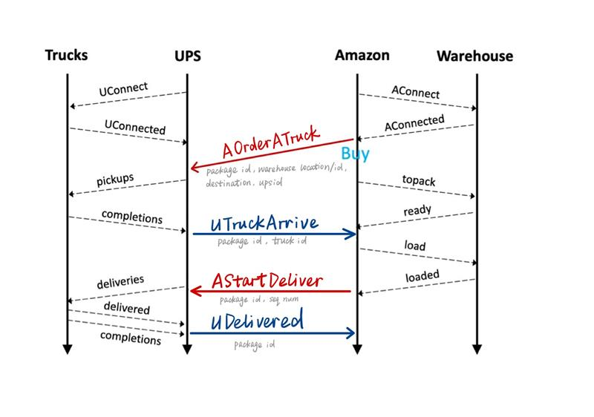

message AOrderATruck{

required int64 packageid = 1;

required int32 warehouselocationx = 2;

required int32 warehouselocationy = 3;

required int32 warehouseid = 4;

required int32 destinationx = 5;

required int32 destinationy = 6;

optional string upsid = 7;

}

message AStartDeliver{

required int64 packageid = 1;

required int64 seqnum = 2;

}

message AUCommand{

repeated AStartDeliver deliver = 1;

repeated AOrderATruck order = 2;

}

message UTruckArrive{

required int64 packageid = 1;

required int32 truckid = 2;

}

message UDelivered{

required int64 packageid = 1;

}

message UACommand{

repeated UTruckArrive arrive = 1;

repeated UDelivered delivered = 2;

}